
Summer Update 2026 update
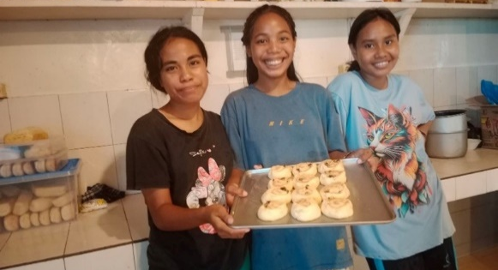
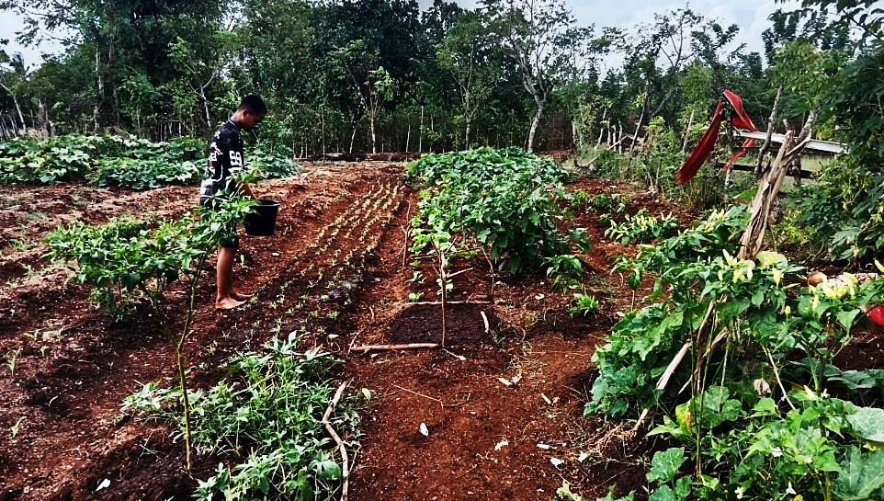
  - Baking
Our baking class with Kim (a Canadian visitor) went well. At first, only few kids wanted to join the class, but the next day many more joined. Soon so many joined they needed to be divided into four groups! They learned how to make cinnamon rolls, and muffins using local vegetables. Some students were surprised that vegetables could be used to make muffins.
The students who live in the village also came for the baking class. Their favourite part was enjoying the muffins and cinnamon rolls together.
This baking class is only short-term, but we want the kids to learn something new and have another experience, which will be useful for them in the future. This baking class also gave them an opportunity to practice their English with a native speaker.

Teaching Life Skills

Mission Statement
Our greatest desire is to see the glory of God advanced in Sumba as we bring the Gospel to the Sumbanese people. Our prayer is that they may, by God’s grace, embrace the Saviour of sinners, Jesus Christ, and have their lives shaped and influenced by the Bible. We desire to see lives improve spiritually and materially as God provides for and blesses us in our work.

Sumba Mission Board Members:
Bill Klyn, Chairman
Peter Koppert, Secretary
Alice Klyn, Treasurer
Henk Koert
William Van Brugge
Bernie Pennings (advisory member)

Liaison members from HRC Mission Committee
John Beeke
Edward Otten
Russ van den Toorn

A lot of learning takes place at the Sumba Mission compound. While we strive for academic excellence at Rehoboth Christian School, we are also aware of the need to teach the students essential life skills. We believe that vocational training gives our students a unique advantage and a sense of creative independence.
  - Gardening
There is very little topsoil in the area around the home and so our gardening project began by carrying rich, black soil up from the valley. Groups of students and their teachers are responsible to plant, water, weed and harvest their part of the gardens. Crops include vegetables, tomatoes, corn, cassava and sweet potatoes.
  - Livestock
Other students are responsible to feed and care for the animals that are kept for meat. There are cows, pigs, goats, chickens, laying hens and catfish. Along with Yandrus, some of the boys built the chicken coop as well as fences to keep the animals out of the gardens.
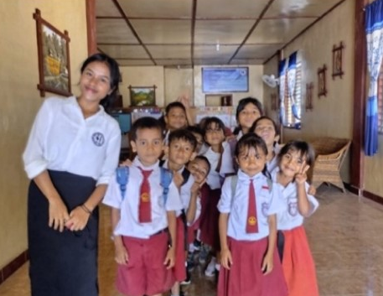
technology
INFORMATION TECHNOLOGY SOLUTIONS
THAT WORK FOR YOUR BUSINESS.
- Mardiana, Grade 4
“I love to see my students show growth in their understanding and attitudes. When I see them grow in character and learn to love God, it motivates me to continue doing my best to improve the quality of their learning.”

- Daniel, Grade 6
“I am deeply grateful to have joined Rehoboth School because here I have gained many valuable experiences and lessons, such as time management, hard work, teamwork, a sense of family, and spiritual growth.”

- Justina, Elementary VP, Christian Education
“I enjoy being able to guide children in learning God’s Word through religious education. I also like conducting lessons outside the classroom so that children can better understand God’s creation through their surroundings.”

- Ester, Elementary Computers
“I try to keep lessons engaging every day to ensure that children can learn about and master technology in this increasingly advanced digital age. The students are very excited when learning about new technologies, even if I only demonstrate them through videos or PowerPoint presentations.”
Sponsor a Teacher
Teachers needing sponsors
Sekolah Kristen Rehobot is a Christian School that strives for educational excellence and practical skills development. Approximately 300 students are enrolled from Preschool to Grade 9.
There are 24 teaching staff at the school. Due to recent government cost-saving measures, the teachers’ salaries, which used to be partially paid by the government, must now be paid by the mission. The average monthly wage per teacher is $190 CAN.
Parents who send their children to the school are very poor and cannot afford to pay for tuition. Some parents are so poor that their children arrive at school without breakfast or lunch, so the school provides a meal for them.
All the teachers at Sekolah Kristen Rehobot have been trained at a Christian teachers’ college and incorporate God’s Word and a Christian worldview into the subjects they teach.
The students from the school generally score high on national tests and show good study habits.
If you are able, please consider sponsoring a teacher or making a monthly contribution towards a teacher’s salary. Sponsorships can be made by completing the sponsorship form on our website:
https://sumbamission.com/donate

Please Pray for Us!
Thanksgiving
- for the new pickup truck received through SDF
- all the children who had the chicken pox have recovered well
- for Arlando’s successful surgeries and recovery
- for an abundant and lengthy rainy season

Prayer Requests
- for more kitchen staff to help prepare meals for 180 people daily
- that each student would learn well and be taught the fear of God by the Holy Spirit
- God’s blessing on travels and plans for Yandrus and Christina to come to Canada this fall, D.V.

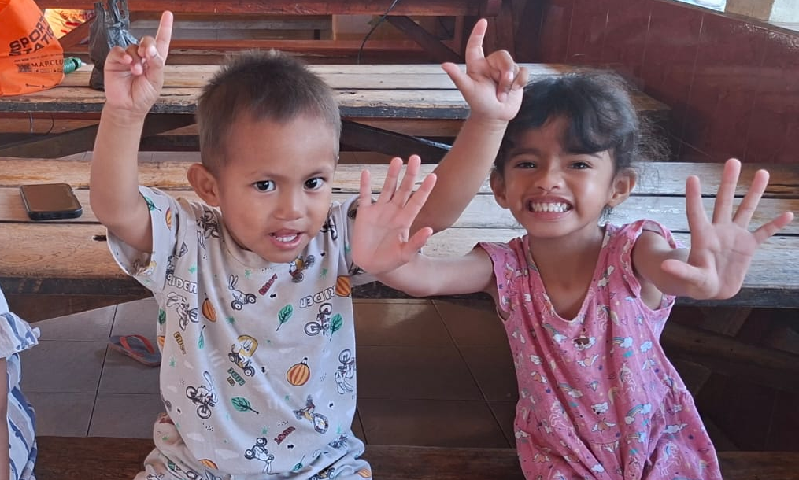
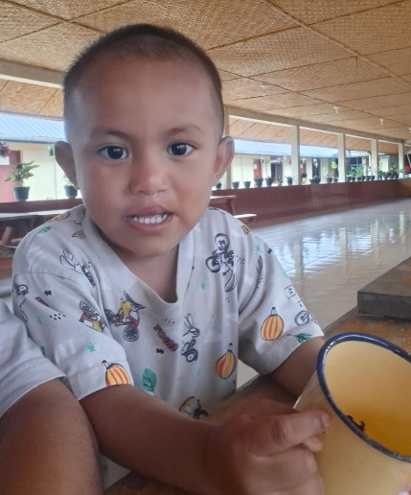
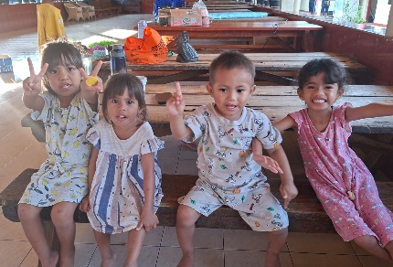
Meet Arlando (left on the photo above)! He came from Manuk, a very remote village—so remote that his home cannot be reached even by motorbike. He was brought to the children’s home because his mother was ill, and his father had left them.
He arrived at the children’s home when he was just one month old, suffering from a cleft lip and cleft palate. He was undernourished and very weak. His stomach could not produce a certain enzyme, so he required special, very expensive milk. Due to his health challenges, Arlando spent most of his first year in the hospital.
When he turned one, we took him to Bali for surgery to repair his cleft lip and cleft palate. After the operation, Arlando began to grow well and is now much healthier. We thank God for blessing the treatments and procedures.
Today, Arlando is a happy, healthy three-year-old. He is one of several children in the home with special needs. Arland is autistic and can only say a few words. Most of his communication is done by pointing and gestures. He laughs and cries and likes to hug the other children.
We believe God brought Arland to us and that He knows and cares deeply for him. We pray that God will bless Arlando so that he may come to know and worship Him.

Meet Arlando!

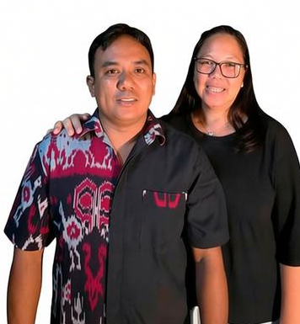
Join us to learn about Sumba Mission with Christina and Yandrus
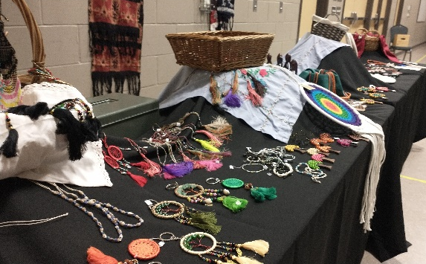
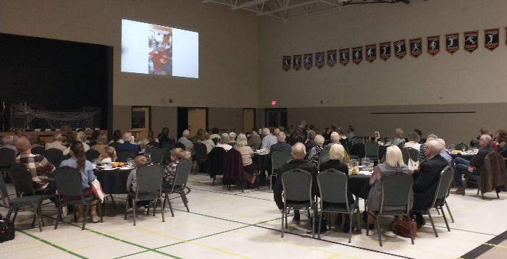
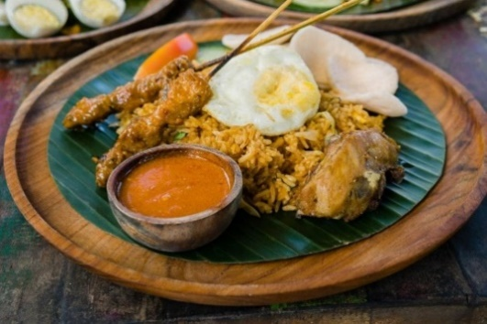
www.sumbamission.com
sumbamission1999@gmail.com
Save the date for a presentation near you later this year, the Lord willing
- Oxford Reformed Christian School: Dinner & Presentation on Friday, October 16th
- Dundas Free Reformed Church: Dinner & Presentation on Friday, October 23rd
- Jordan Christian School: Dinner & Presentation on Friday, November 6th
Christina has been at the mission since it started in 1999. Over the past 26 years she has worked in many different capacities at the mission. She is currently the principal of the mission school and operations manager of the mission. The children in the home call her Mami.
In 2012, she married Yandrus who has since taken on a leadership role in the mission as well. He enjoys teaching hands-on skills such as carpentry, building, welding and farming to the children.

E-transfer deacons@hrc.church
Please include your name and address in the message section.

To financially support this work in Sumba, Indonesia cheques can be sent to:

Burgessville HRC
PO Box 105
Burgessville ON N0J 1C0
(Memo: Sumba Mission)

